I have created a web app using angularjs and GoLang (Server side code).

I have used Golang’s default web server.

To make webserver of golang operational please enter the following command in the corresponding folder

**go run tag.go inputStruct.go outputStruct.go priorityQueue.go**

Please wait until CMD/terminal shows “Done with storing data” message.

AngularJS:

Step 1: Please execute the following command “npm install” in Clarifai folder

If it is still throwing errors. Please try executing the following commands

npm install @angular/material –save

npm install @angular/cdk –save

Step 2: please execute ng-serve .

Step 3: Go to localhost:4200 using google chrome.

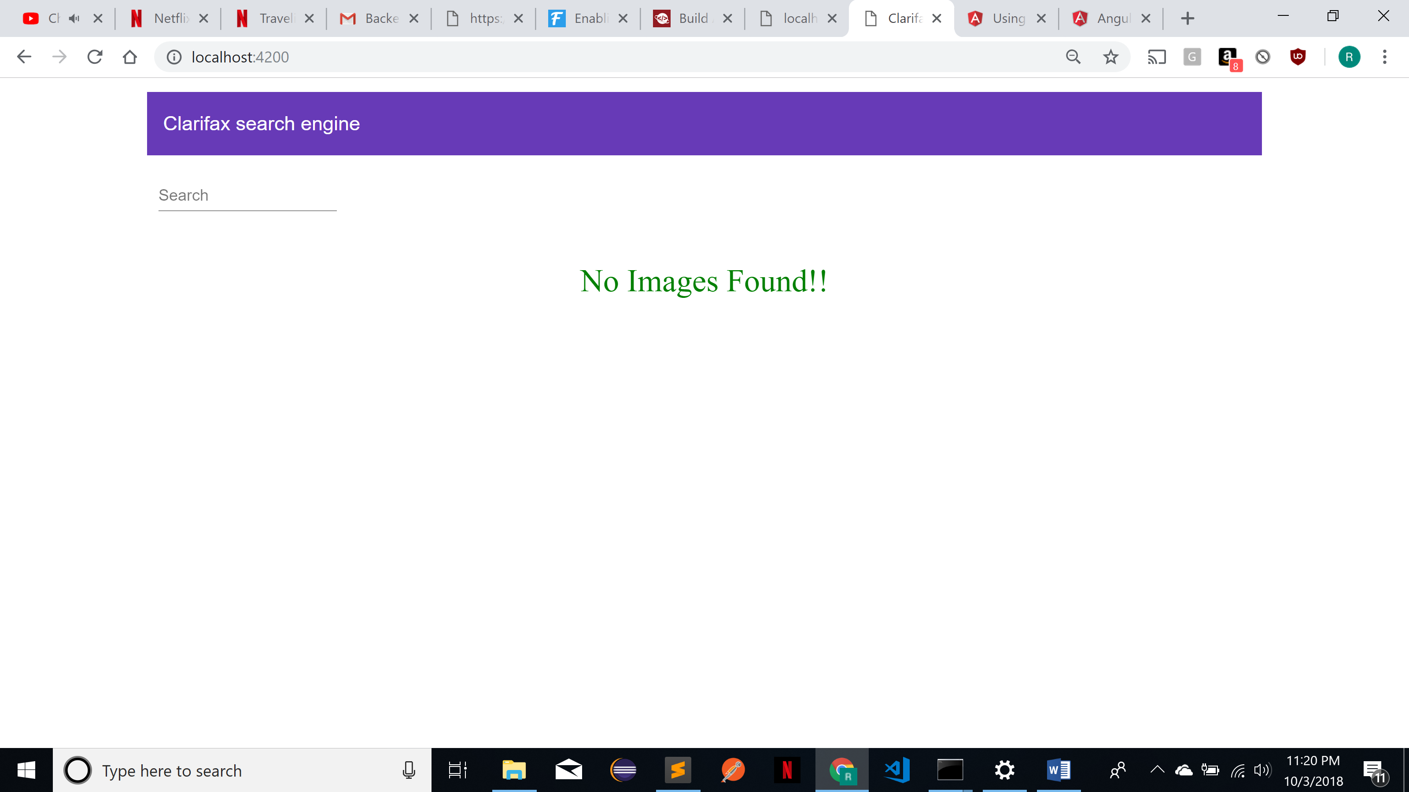

Screen as shown above appears.

Please enter search word

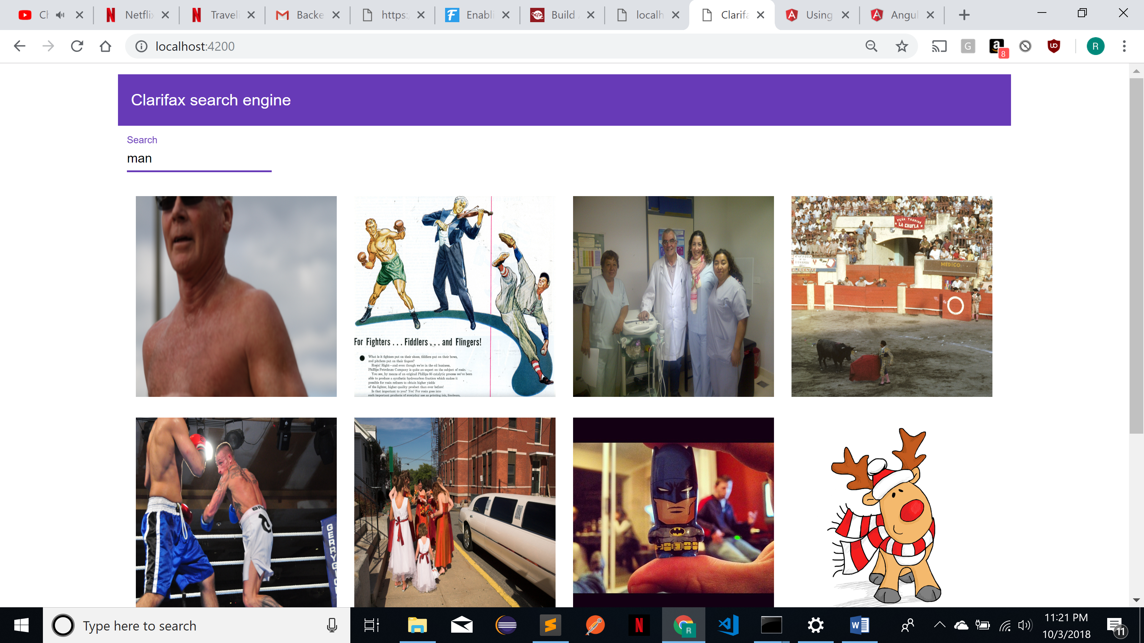

A web page similar to above screen will appear. If you hover over image you would be able to see the probability of the image for that particular tag.

Efficiency of retrieving data:

O(10) which is constant time. Since API have to display 10 most probable pictures. Stored the tag name and corresponding pictures in map of heap with key being the key name and heap contains the url of the image.

Storing data:

O(log10 * no of tags for each image)

In order to store the image url in the heap I have to make sure that probability of the image is among the top ten probable images having same tag name.

MVP could be improved by including dictionary of similar words such as New York, NEWYORK, NY so that they tend to return the same images.